Hatchet Vocabulary Work
Instructions: Complete each column for each vocabulary word from Hatchet. The context is provided. The first word is completed for you as an example.
Text from  Hatchet  with Vocabulary Word  underlined | #1: Prediction of  Word’s Meaning  Don’t forget  the part of speech!  Noun: person, place, thing  Verb: action word  Adjective: describing word  Adverb: how, how often, how much | #2: Dictionary Definition  Don’t forget  the part of speech!  Noun: person, place, thing  Verb: action word  Adjective: describing word  Adverb: how, how often, how much | #3: Synonym  Based on the dictionary definition. | #4: Antonym  Based on the dictionary definition.
When a plane went down they mounted extensive searches and almost always they found the plane within a day or two. | (adjective) covering a lot of area, thorough | (adjective) covering or affecting a large area | vast | small
Probably come in here with amphibious planes, small bush planes with floats that could land right here on the lake and pick him up and take him home.
There was nothing obvious to eat and aside from about a million birds and the beaver he hadn't seen animals to trap and cook...
All Perpich would say is that I have to get motivated. He was always telling kids to get motivated.
You are your most valuable asset.
State one or more details from the text to support your understanding of Brian’s family situation.
Pull from ideas that are directly stated or ideas that you have inferred from clues in the text.
Pull from ideas that are directly stated or ideas that you have inferred from clues in the text.

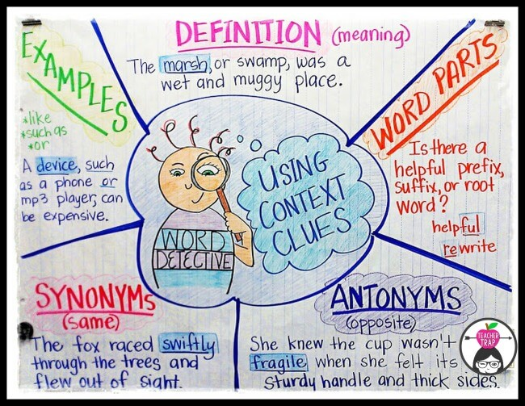  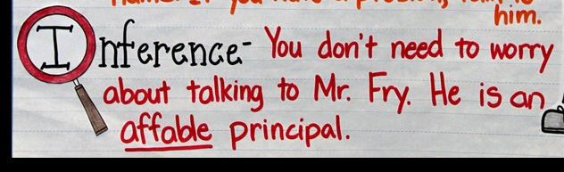 | TYPE OF CONTEXT CLUE | EXAMPLE
 | Definitions:  Tells the Meaning | “...she loosened me and my classmates from the safe anchorage of the desks…”
 | Examples:  Samples or Patterns | “Every attempt to stop the spread of Christianity with the threat of persecution and death…”
 | Word Parts:  Prefixes, Roots, Suffixes | “Two of his pursuers had gone back to harness the remaining dogs…”
 | Synonyms:  Mean the Same | “Caesar’s genius at entertaining the masses… He bought the affection of the people… spectacles that were open and free to the public… established the precedent of keeping the populace occupied…”
 | Antonyms:  Mean the Opposite | “...I had to decide whether she was a possible friend or a menace.”
 | Inferences:  Use evidence and reasoning | “All this gave Caesar unlimited power and established the precedent of keeping the populace occupied…”

